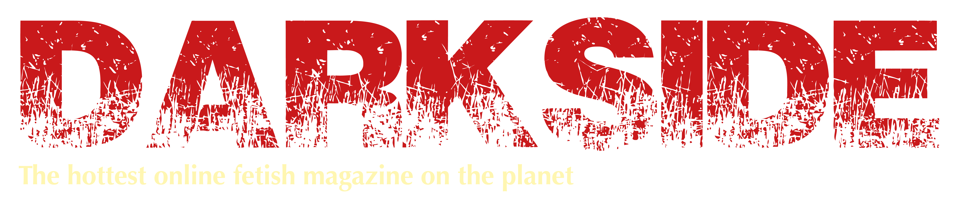

Model Release Form
Darkside Magazine

I hereby give permission to * to use my name and
photographic likeness for use in Darkside Magazine and in promotional literature,
advertising, or similar ways which are linked to this publication. *Photographer’s name

I hereby warrant that I am over eighteen (18) years of age, and am competent to
contract in my own name.

I have read and understand the above:

Signature: _______________________________________________
Printed name: _____________________ Date: ________________
Photographer: __________________________________________

Disclaimer: Above information is held in confidence and is never released or sold.

Please print, scan and email this completed form to paul@darksidemag.net along with your photographs.

